Gantt Chart

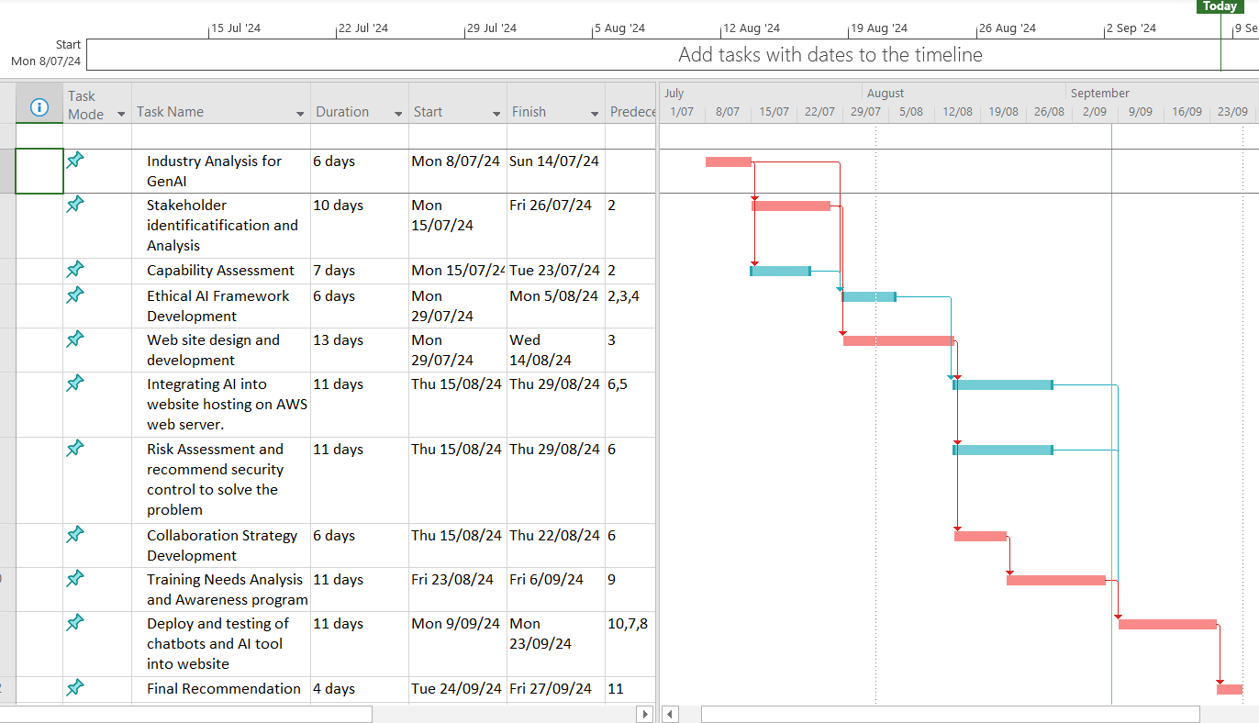

Fig. Project Gantt Chart

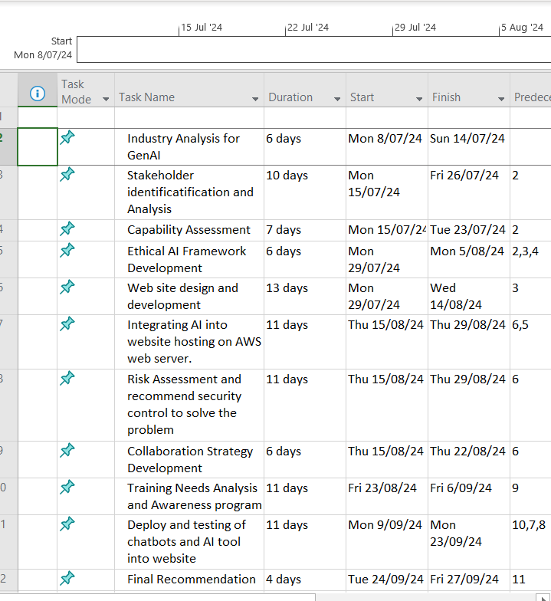

Fig. WBS and Tasks with start and finish date.

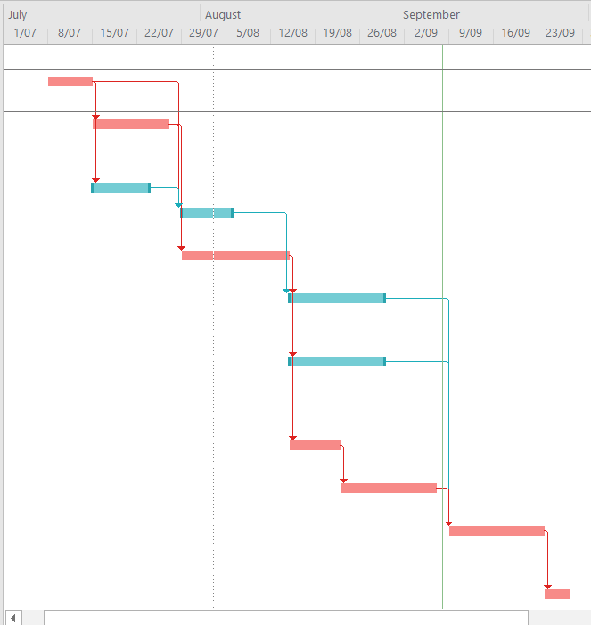

Fig. Project Gantt Chart Diagram

Project Network Diagram

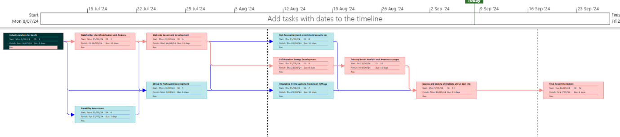

Fig. Project Network Diagram showing critical path.

Network Diagram Detail View

